

SMART PARKING
TEAM MEMBER
732721106034 : SATHYA.R
PHASE 3 SUBMISSION DOCUMENT
PROJECT : SMART PARKING
This document presents an innovative solution to enhance the efficiency and reliability of smart parking systems by incorporating predictive maintenance algorithms. By utilizing sensor data and advanced algorithms, our solution aims to anticipate maintenance needs, reduce downtime, and improve overall user experience.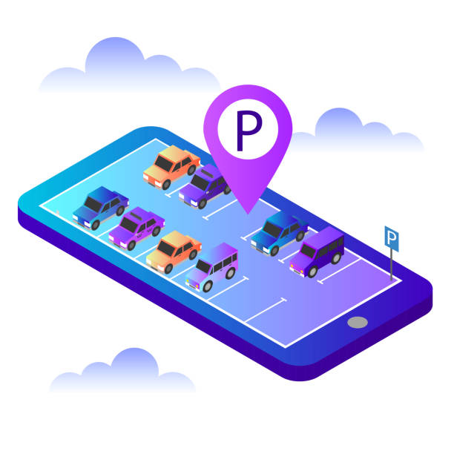
INTRODUCTION:
Smart parking systems have revolutionized urban mobility by optimizing parking space usage and enhancing convenience. However, they are susceptible to equipment failures, causing disruptions and inconvenience to users. To address this issue, we propose the integration of predictive maintenance algorithms, which can anticipate potential maintenance requirements before they lead to system failures.
1. Hardware Setup:
Acquire the necessary hardware components, including Raspberry Pi, ultrasonic sensors, and other peripherals.
Connect the ultrasonic sensors to the Raspberry Pi. Ensure that you have the required wiring and power supply for the sensors.
2. Raspberry Pi Setup:
Install the Raspberry Pi OS (Raspbian or Raspberry Pi OS) on your Raspberry Pi if it's not already done.
Update the Raspberry Pi software to the latest versions:
sql
Copy code
sudo apt-get update
sudo apt-get upgrade
3. Interface with Ultrasonic Sensors:
Write Python scripts to interface with the ultrasonic sensors. You can use libraries like RPi.GPIO to control the GPIO pins.
Configure the sensors to measure the distance to nearby objects, which will help detect parking space occupancy.
4. Data Collection:
Develop Python scripts to collect data from the ultrasonic sensors. You will measure the distance from the sensor to the ground or an obstruction (e.g., a vehicle).
Store the collected data in variables or data structures for further processing.
5. Data Processing:
Implement logic to determine parking space occupancy based on the data from the sensors. You can set a threshold distance below which a parking space is considered occupied.Create data structures to keep track of parking space statuses, such as a dictionary with parking space IDs and their occupancy status.
6. Cloud Integration:
To send data to the cloud, you'll need to choose a cloud platform (e.g., AWS, Azure, Google Cloud) and set up an account.
Write Python scripts to send parking space occupancy data to your chosen cloud platform. You may use APIs or MQTT protocols for this purpose.
7. Mobile App Integration:
If you plan to develop a mobile app for users to check parking space availability, start designing and building the app. Use appropriate development tools and languages for your chosen mobile platform (e.g., Android, iOS).
8. Data Visualization:
Create a dashboard or user interface to visualize the parking space occupancy data. You can use web technologies like HTML, CSS, and JavaScript or mobile app development frameworks.
9. Testing and Calibration:
Test the entire system to ensure that the sensors are accurately detecting parking space occupancy and sending data to the cloud or mobile app.
Calibrate the system as needed to improve accuracy.
10. Documentation:
Document your hardware setup, software architecture, and data flow for future reference and troubleshooting.
11. Security:
Implement security measures to protect the data and system integrity, especially when sending data to the cloud or mobile app.
12. Scale and Optimize:
Consider how to scale the system for a larger parking area if needed.
Optimize the code and system performance for real-world usage.
13. User Feedback:
Gather feedback from users during the testing phase and make improvements based on their input.This is a high-level overview of the development process for your smart parking system. As you work through these
steps, you may encounter specific challenges and opportunities for customization based on your project's requirements and goals.

